* Test Plan
* Test Data
* Test Log
* Documentation for other programmers (C# Doc)
* On screen help to guide users

Note: Documentation for other programmers is located in folder “C#DocAppPawel”

[JavaDocMessAppPawel\index.html](JavaDocMessAppPawel/index.html)

and on screen help window shows up when user clicks “Help” button.

**Test Plan**

|  |  |
| --- | --- |
| **Software component name:**  **Application**  **Date: 26.03.2019** | Version number: 00001 **Tester name: Pawel Gajewski** |

|  |  |  |  |
| --- | --- | --- | --- |
| **Test No:** | **Purpose / Test type** | **Input** | **Expected output** |
| **1** | Checking if the button does the right method | Click “Help” button | Open new window displaying users help text. |
| **2** | Checking if the button does the right method | Click “Send” button | Send message. Display window with success message and save message to a file. |
| **3** | Check the correct recipients number is inputted | Input incorrect value:  “absdefg” | Error window should come up with message about the error. |
| **4** | Check the correct recipients number is inputted | Input correct value:  “+3533434343434” | Should be no error displayed when submission is made by clicking the “send” button. |
| **5** | Check that text area contains any message to send. | Leave field blank | When submitting the error should come up that message is empty. |
| **6** | Check that text area contains any message to send. | Type in some message | When making submission there won’t be error message displayed. |
| **7** | Check if SMS and MMS radio group works | Pick “MMS” message | Should make visible file picker so user can choose the file attachment to send |
| **8** | Check if SMS and MMS radio group works | Pick “SMS” message | File picker button should not be visible for text message |

**Test Data**

|  |  |
| --- | --- |
| **Software component name:**  **Application**  **Date: 26.03.2019** | Version number: 00001 **Tester name: Pawel Gajewski** |

|  |  |
| --- | --- |
| **Test Data No: 1** | 1. **Help button** |
| **Field Name** | **Input Value** |
| 1. Help button | “Help” button clicked once |

|  |  |
| --- | --- |
| **Test Data No: 2** | 1. **Send button** |
| **Field Name** | **Input Value** |
| 1. Send button | “Send” button clicked once |

|  |  |
| --- | --- |
| **Test Data No: 3** | 1. **Phone validation** |
| **Field Name** | **Input Value** |
| 1. Phone validation | Input incorrect value: “absdefg” |

|  |  |
| --- | --- |
| **Test Data No: 4** | 1. **Phone validation** |
| **Field Name** | **Input Value** |
| 1. Phone validation | Input correct value: “+3533434343434” |

|  |  |
| --- | --- |
| **Test Data No: 5** | 1. **Message validation** |
| **Field Name** | **Input Value** |
| 1. Message validation | Leave field blank |

|  |  |
| --- | --- |
| **Test Data No: 6** | 1. **Message validation** |
| **Field Name** | **Input Value** |
| 1. Message validation | Type in some message |

|  |  |
| --- | --- |
| **Test Data No: 7** | 1. **Radio group validation** |
| **Field Name** | **Input Value** |
| 1. Radio group validation | Pick “MMS” message button from the radio group |

|  |  |
| --- | --- |
| **Test Data No: 8** | 1. **Radio group validation** |
| **Field Name** | **Input Value** |
| 1. Radio group validation | Pick “SMS” message button from the radio group |

**Test Log**

|  |  |
| --- | --- |
| **Software component name:**  **Application**  **Date: 26.03.2019** | Version number: 00001 **Tester name: Pawel Gajewski** |

|  |  |  |  |
| --- | --- | --- | --- |
| **Test No:** | **Date** | **Actual output** | **Comments** |
| **1** | 26.03.2019 | Clicking “Help” button opened new window displaying users help text.  **Screen: “Test 1.jpg”** | Worked as expected. |
| **2** | 26.03.2019 | Clicking “Send” button validated and displayed success window that the message was sent. Also created the data file in the directory named “MessAppMessages.dat”  **Screen: “Test 2.jpg”** | Worked as expected |
| **3** | 26.03.2019 | Inputted incorrect value: “absdefg” caused program to display error message and only correct pattern is accepted.  **Screen: “Test 3.jpg”** | Validation working correctly. For future updates we could change the pattern required. |
| **4** | 26.03.2019 | Inputted correct value:“+3533434343434”  Lets the user send message without displaying error message | Worked as expected.  Note: no screen needed for this test |
| **5** | 26.03.2019 | Blank filed left in message area caused program to display error message that application will not accept blank message.  **Screen: “Test 5.jpg”** | Does not make sense to send empty message. |
| **6** | 26.03.2019 | Application accepts messages no longer that 160 characters.  And displays number of characters left to reach the limit. | Worked as expected  Note: we can see from previous screens that word counter is working correctly. |
| **7** | 26.03.2019 | Picking “MMS” message makes file picker button visible and lets user to choose desire attachment to send.  **Screen: “Test 7.jpg”** | Worked as expected |
| **8** | 26.03.2019 | Picking “SMS” message hides file picker and user can send sms message.  **Screen: “Test 8.jpg”** | Worked as expected |
| **9** | 26.03.2019 | Starting application without data file resulted in message displayed that we are using application for the first time.  **Screen: “Test 0.jpg”** | This test was not on the plan, but occurred at the start of application when running for the first time. |

**Test Evidence**

**Test 0.jpg**

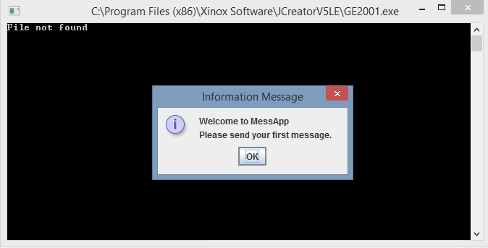

**Test 1.jpg**

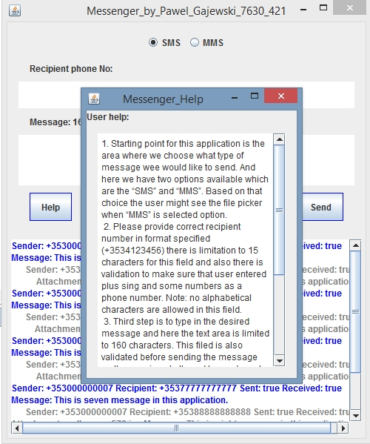

**Test 2.jpg**

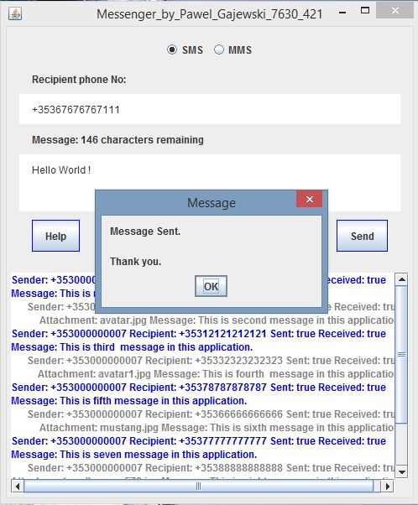

**Test 3.jpg**

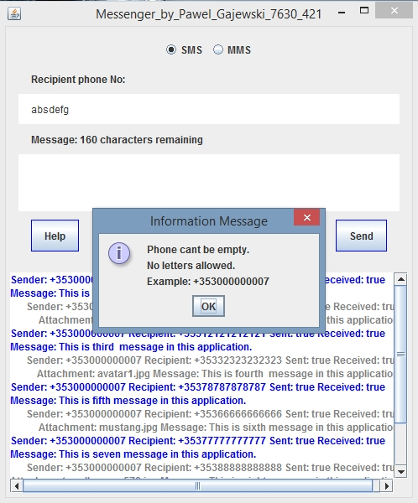

**Test 5.jpg**

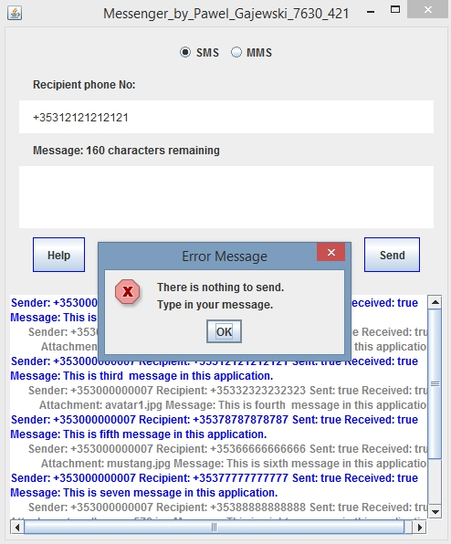

**Test 7.jpg**

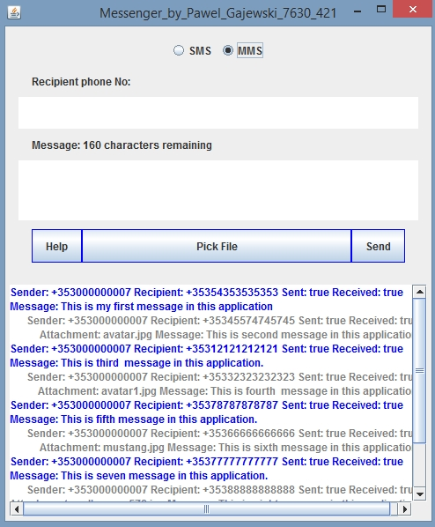

**Test 8.jpg**

